Damaged-Undamaged Classification Through One Step Ahead Forecasting Using LSTM
Train Parameters:
Epochs: 20
Batch_Size = 32
Window_size: 30
Step_size: 1
Train Results:
Threshold : 0.07065512
Train MAE mean: 0.01794571
Test (Damaged) MAE mean: 0.11411099
Detected damaged windows:
window_index mae_loss threshold anomaly
0 0 0.092457 0.070655 True
1 1 0.098756 0.070655 True
2 2 0.103257 0.070655 True
3 3 0.088560 0.070655 True
4 4 0.088976 0.070655 True
5 5 0.088329 0.070655 True
6 6 0.086262 0.070655 True
7 7 0.096823 0.070655 True
...
[48037 rows x 4 columns]

--- Other Results ---
Accuracy: 0.9995 - The rate of correct predictions.
Precision: 0.9995 - The rate of how many predictions made on the damage are true.
Recall: 1.0000 - Missing Value, the model points most damaged values as undamaged.
F1 Score: 0.9997 - The F1 score is the mean of Precision and Recall.

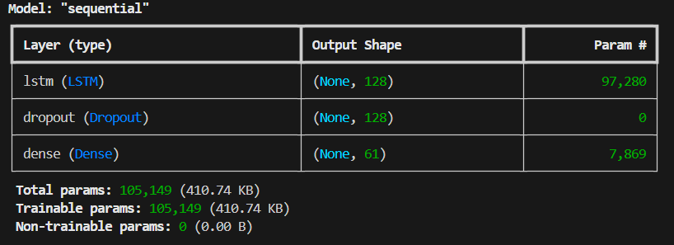

The Confusion Matrix:
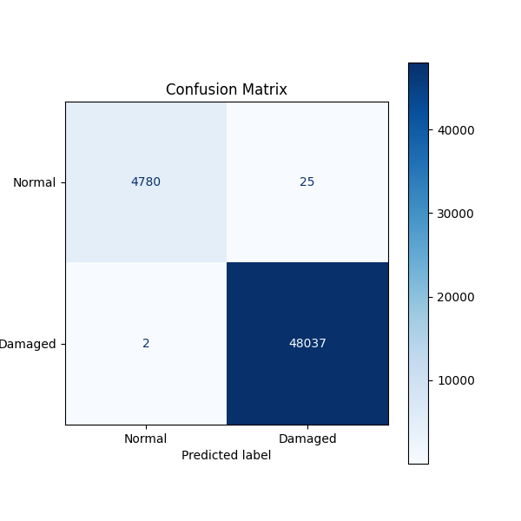

Validation and Loss Graphs:
